Ashvini Krishnan

NetID: akrshnn6

ASTR 414 HW 8

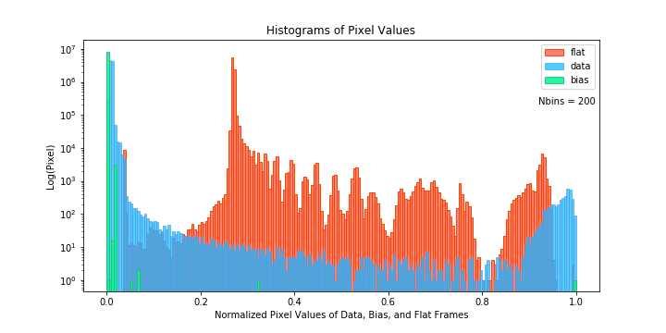**Histogram Plot:**

**Figure 1:** Histogram of pixel values for data, bias and flat frames.

**FITS Images:**

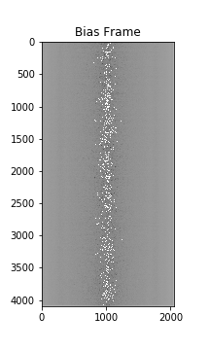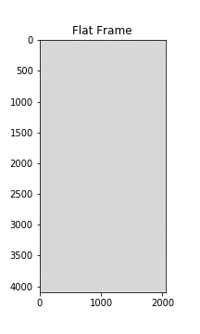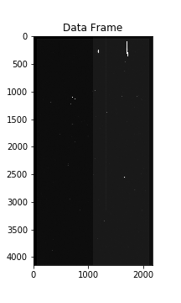

**Figure 2:** Data, Bias and Flat frame images with log scaling